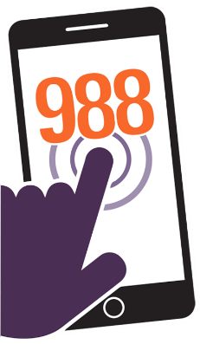
Urgent Action Needed
988 and Strengthening [STATE’S] Crisis Response System

Even before the pandemic, suicide and overdose rates had risen to historically high levels, and incidents of mental health challenges among Americans were increasing. To address these issues and better connect people to appropriate care by trained mental health professionals, Congress designated 988 as the new three-digit crisis number for mental health emergencies. But a number alone is not enough.
Ahead of the July 2022 launch of 988, [STATE] must begin building a comprehensive infrastructure that includes someone to answer the call, someone to come help, and someplace to go for care.

The need is growing.
- With Americans reporting increased depression, anxiety, financial strain, social isolation, substance misuse, and suicidal ideation amid the pandemic—and with increases in completed suicides among certain populations, such as Black youth—now, more than ever, we need to get people help when and where they need it.

One number to call.
- When 988 goes live nationwide in July 2022, it will be the three-digit number to call when you or someone you know is experiencing a mental health emergency.
- For example, when someone is having suicidal thoughts, experiencing delusions, or displaying severe symptoms of a mental health condition, 988 will be available to connect them with the help they need.

More than a number, 988 is a pathway to compassionate care.
- 988 is not only about answering calls—it’s also about making appropriate and accessible referrals, creating a system of mobile crisis teams, and offering crisis stabilization programs that connect people to a continuum of care at critical moments.
- Fully implemented, 988 will reduce avoidable emergency department or hospital admissions for people in crisis and avoid traumatic, often deadly, engagements with the criminal justice system.

A more effective allocation of resources.
- A comprehensive 988 system will not only save lives, but also preserve important local, state, and federal resources.
- In 2017, an average of 10% of law enforcement agencies' total budgets and 21% of staff time were spent responding to and transporting persons with mental illness (Treatment Advocacy Center).
- In contrast, a key mobile response program in Oregon—which sends a medic and a mental health crisis counselor to attend to immediate mental health issues, de-escalate, and help formulate a plan—cost $800,000 in 2018, less than 2% of the annual police budget (Wall Street Journal).

More than half of Americans support sending specialized crisis teams to respond to mental health crises instead of police, according to a recent Harris Poll survey.

Time for action is now.
988 will only be effective in [STATE] if lawmakers take steps now to develop and fund an effective crisis response infrastructure that includes three key components:
Someone to answer the call. 24/7 call centers adequately staffed by specially trained individuals to respond to a range of mental health crises.

Someone to come help. Mobile crisis teams that can be dispatched to the scene and are equipped to effectively assist people in crisis.

Someplace to go for care. Crisis stabilization services to provide observation as well as connection to follow-up care.

Learn more: www.TheKennedyForum.org/988Toolkit

This material, developed by the nation’s leading mental health advocacy organizations and professional associations (“The CEO Huddle”), reflects alignment with the U​nified Vision for the Future of Mental Health, Addiction, and Well-Being in the United States. To access more 988 resources, please visit www.TheKennedyForum.org/988Toolkit.

